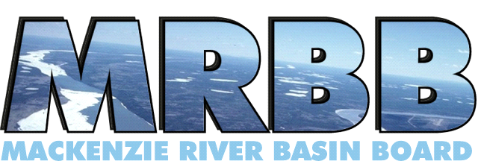

The Board’s Vision: A healthy and diverse aquatic ecosystem

for the benefit of present and future generations.

**Mackenzie River Basin Board Secretariat**

**Draft Agenda, Mackenzie River Basin Board Meeting No. 83 Supplemental**

**Microsoft Teams:** [**Join the meeting now**](https://teams.microsoft.com/l/meetup-join/19%3ameeting_NzViZWIyNmYtMjc4YS00ZDgwLWIyMmUtZGU1ZDc5ZDI2OWEx%40thread.v2/0?context=%7b%22Tid%22%3a%22740c5fd3-6e8b-4176-9cc9-454dbe4e62c4%22%2c%22Oid%22%3a%22b9570524-18bd-4adf-8fa8-7e6ce3d7dab0%22%7d)

Meeting ID: 230 909 282 333 2

Passcode: gU7jJ3Yc

**Dial in by phone**

[+1 587-416-3446,,139500909#](tel:+15874163446,,139500909) Canada, Edmonton

Phone conference ID: 139 500 909#

**Join on a video conferencing device**

Tenant key: [teams@ec.video.canada.ca](mailto:teams@ec.video.canada.ca)

Video ID: 114 542 545 9

**83S.1** **Welcome Roundtable –** P. Cherneski

(Goal 9) (10 minutes)

* Changes or updates to membership

**83S.2** **Agenda** (Decision) **–** P. Cherneski

(Goal 9) (5 minutes)

**83S.3**  **Routine Budget** (Decision) - P. Cherneski and P. Siwik

(Goal 9) (20 minutes)

**83S.4**  **SOAER Update Discussion** (Information and Decision) -P. Siwik, J Cederwall

(Goal 1) (60 to 80 minutes)

* Envelope for SOAER update
* Draft outreach letter
* 5 Year Budget Forecast

**83S.5** **Look Ahead** (Information and Decision) - P. Cherneski

(Goal 9) (5 min)

* Meeting 84 – in-person meeting in Yellowknife/Dettah; June 18 and 19, 2025
* Meeting 85 – virtual with focus on SOAER SoW – Oct. 2 and 3, 2025
* Meeting 86 – virtual with focus on focus on Agency Reports – Nov 19 and 20, 2025

**83S.6** **Meeting Close**

**Goal 1. Evaluate the health of the whole basin**

**Goal 2. Investigate matters concerning the ecological health of the whole basin**

**Goal 3. Advocate for the maintenance and improvement of the ecological health of the whole basin**

**Goal 4. Educate the public, share information, and learn from others about matters concerning the ecological health of the whole basin**

**Goal 5. Support and facilitate the increased participation of Indigenous Peoples in MRBB activities**

**Goal 6.** **Encourage the development and implementation of bilateral water management agreements**

**Goal 7. Ministers, Indigenous leaders and appropriate staff of jurisdictions are informed of and engaged in MRBB activities**

**Goal 8. Information, knowledge and research are shared among jurisdictions – written reports**

**Goal 9. MRBB affairs are administered effectively.**