Mackenzie River Basin Board Strategic Plan from 2025-2030 and beyond
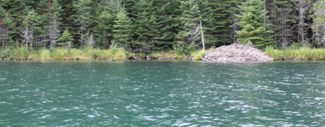

About the Mackenzie River Basin Board
The Mackenzie River Basin Board (MRBB) was established to implement the Mackenzie River Basin Transboundary Waters Master Agreement (Master Agreement), signed in 1997. The MRBB has thirteen members, three representing the federal government and ten representing the five provinces and territories including Yukon, Northwest Territories, British Columbia, Alberta and Saskatchewan in the Mackenzie River Basin. Each of the five provinces and territories has one member who represents their governments and one member who represents an Indigenous perspective (First Nations, Métis and Inuit) from their Nation and communities. Collectively the MRBB members have a wealth of experience and knowledge who are committed to supporting a healthy aquatic ecosystem in the Mackenzie River Basin. Several members live in the Basin and some live on the land.

Driven by the Master Agreement, the MRBB’s key responsibilities are to:
- Provide a forum for communication, coordination, information exchange, notification, and consultation among all six jurisdictions and the public
- Recommend uniform objectives or guidelines for the quality and quantity of water resources
- Encourage consistent monitoring programs
- Monitor the progress of implementing the bilateral water management agreements between neighboring jurisdictions
- Submit a report on the state of the aquatic ecosystem every five years to the federal, provincial, and territorial Ministers
- Conduct studies and investigations, as required

The MRBB’s Vision for the Mackenzie River Basin is to support, maintain and promote a healthy and diverse aquatic ecosystem for the benefit of present and future generations.

The MRBB’s Guiding Principles are:
- To manage the water resources in a manner consistent with the maintenance of the ecological integrity of the aquatic ecosystem.
- To manage the use of the water resources in a sustainable manner for present and future generations.
- To allow each Party to the Agreement to use or manage the use of water resources within its jurisdiction, such use does not unreasonably harm the ecological integrity of the aquatic ecosystem in any other jurisdiction.
- To provide early and effective consultation, notification and sharing of information on developments and activities that might affect the ecological integrity of the aquatic ecosystem in another jurisdiction.
- To resolve issues in a cooperative and harmonious manner.

About the Mackenzie River Basin

The Mackenzie River Basin (MRB), Canada's largest basin covers approximately 20% of the country's landmass. Spanning five provinces and territories, it encompasses nine major lakes and three large deltas. The eastern portion features three of Canada's largest lakes: Great Bear, Athabasca, and Great Slave. The Mackenzie River and its tributaries flows 4,241 km from the Columbia Icefield to the Beaufort Sea. Permafrost underlies about 75% of the basin. Development has progressed from upstream to downstream, unlike most southern Canadian rivers, creating unique jurisdictional challenges.

While the issues vary at the subbasin level in this immense, diverse geography at the whole basin scale areas of concern include:
- Human development and basin impacts: Water quality, quantity, and traditional uses are affected by resource uses, e.g. oilsands, hydroelectric development.
- Climate impacts: Droughts, floods, forest fires and thawing permafrost affect flow regimes and sediment loads resulting in climate change affects across the entire basin.
- Biota changes: Climate change and invasive species impact aquatic life.
Indigenous peoples have shared they have a deep connection to the environment, the land and especially water, which is essential for their spiritual, cultural, sustenance, and economic needs. Indigenous peoples have a holistic view and thereby rely on a healthy aquatic ecosystem for all aspects of their lives. Water management decisions and changes to water are of high interest to Indigenous peoples. Changes to water are from both climate change and development; it is the cumulative effect of the changes to water that affect traditional uses.
The basin faces challenges due to human activities and climate change. Protecting its ecological health and meeting the needs of its diverse population requires effective water management strategies including water and ecosystem health monitoring that consider both Indigenous knowledge and scientific understanding.
The MRBB Strategic Plan Model – Overview of Foundational Elements and Mechanisms
The strategic plan is based on four foundational elements. The foundational elements align with the commitments made by government members in the Master Agreement, 1997 and reflect the guiding principles. In fact, the foundational elements have guided the MRBB’s approach to governance and administration since 2020, following an external review of the MRBB’s function. These foundational elements are now formalized in the MRBB’s 5-year Strategic Plan.

Since the strategic directions established in 2025 are over-arching and longer-term in nature the plan will be reviewed in 2030 for ongoing relevancy such that the Strategic Plan may be extended to a 10-year horizon. A table of high-level commitments is in the annex and will be revised and updated from time to time.

The MRBB’s Strategic Plan has five strategic directions 1) Reconciliation, 2) Climate Change, 3) Education and Outreach, 4) Investments and Partnerships and 5) Social Health and Wellbeing. These strategies are structured on four foundational elements, described below, that include:
- Reconciliation
- Place-based focus for management and decisions
- Basin-wide perspective
- Basin-wide collaboration
Reconciliation – The MRBB recognizes the significance of the basin to Indigenous peoples. The MRBB advocates in support of Indigenous voices and integrates reconciliation into MRBB governance, and embraces, promotes and respects Indigenous Knowledge and perspectives from Indigenous peoples who live on the land and practice traditional ways of life.

Place-based focus for management and decisions – Aligned with guiding principles above, the MRBB recognizes the importance of considering the cumulative effects on downstream basin residents and Indigenous peoples. The MRBB understands that better decisions are made when downstream effects and neighbouring jurisdictions are considered in the decision making of each jurisdiction.
Basin-wide perspective - The MRBB focuses on basin-wide patterns and trends and communicates on a basin-wide scale. A basin-wide lens creates a feedback loop from downstream provinces and territories to upstream provinces and territories. Considering basin-wide patterns and trends provides a holistic view.

Basin-wide collaboration - A collective approach strengthens collaboration, through information sharing and open dialogue, to advance shared priorities. All members come to the table with collaboration as a primary principle and represent the MRBB to stakeholders with a basin-wide lens.
Additionally, there are four mechanisms to support the implementation of the Strategic Plan. It is through these four mechanisms and the foundational elements that the objectives of the strategic directions will be achieved, refer to the graphic that follows.

The four mechanisms are:
- Ways of knowing: The MRBB, through the State of Aquatic Ecosystem Report, respects multiple ways of knowing through the braiding of Science and Indigenous Knowledges.
- Communication is an important way to achieve the MRBB’s strategic directions. This is achieved through outreach with the public and stakeholders or by organizing expert panels and webinars on key topics such as climate change. Effective communication approaches and tools are integral to overall success.
- Innovation: The MRBB will function as a forum to advance innovative approaches aimed at improving environmental management in the basin. The MRBB will advocate for innovative approaches to improve outcomes, such as research and application in using clean technologies or natural infrastructure to adapt to a changing climate.
- Technology: The MRBB recognizes that much of its success resides with the strength of its secretariat. The secretariat, for its administrative responsibilities, will seek to use innovation and technology to streamline administrative burden to optimize its limited resources and maximize its outputs.

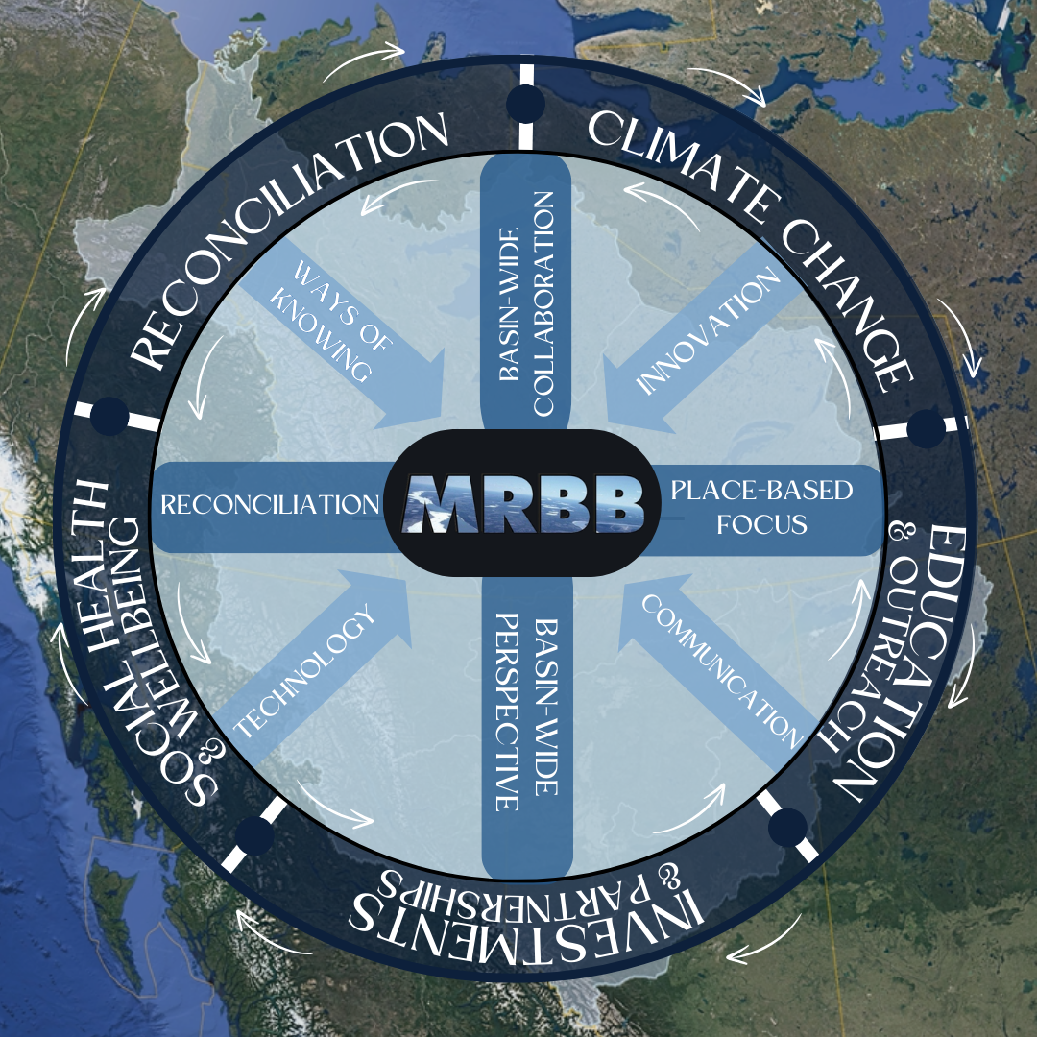
MRBB’s Strategic Plan Diagram: The outer circle are the five strategic directions with four foundational elements and four mechanisms or channels to support its implementation

The MRBB’s strategic directions are:

- Strategy for Reconciliation
Strategically advance reconciliation through meaningful work of the MRBB, by aligning and modernizing governance, and through braiding multiple knowledge systems.

What do we gain by working together:
- We will collectively help governments move forward on the reconciliation spectrum. Through working together, we help build trust and improve the relationship between all levels of government and Indigenous peoples.
- Through modernizing the MRBB’s governance to align with the United Nations Declaration on the Rights of Indigenous Peoples, advances reconciliation, and helps ensure the status and rights of Indigenous peoples are upheld at the Mackenzie River basin scale.
- Ensuring that multiple knowledge systems are reflected in our actions and communications because diverse perspectives lead to more holistic understanding

- We will strive to embody a government-to-government-to-government relationship with members and other governments.

Benefits of realizing strategy:
Braiding knowledge systems means the work done by the MRBB is robust, pertinent, and reflective of the values of Indigenous peoples throughout the Mackenzie River Basin. The MRBB serves as a leading example of co-governance that values and respects the views and contributions of Indigenous governments and organizations. Environmental tracking, issues and potential solutions are considered from an broad ecological perspective.

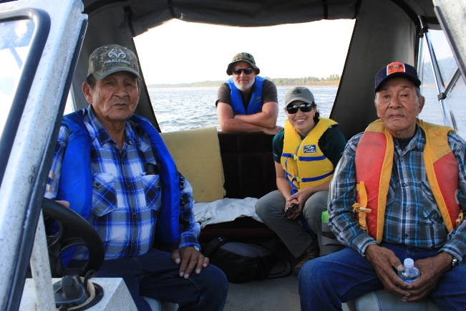
Figure 1: Elders from Fort Chipewyan Note: all photos by N. Stiller (place holders)

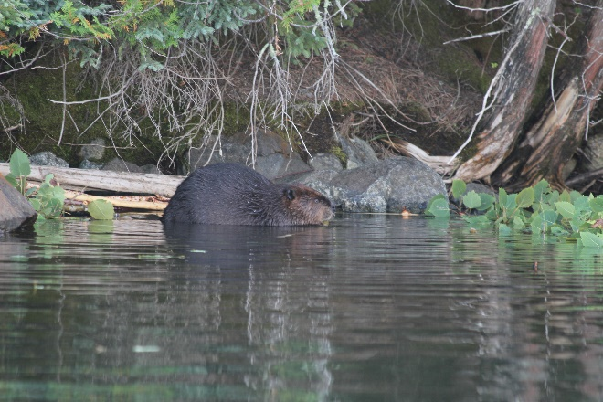

- Strategy on Climate Change
The MRBB will collaborate to develop a common and wholistic understanding of the impacts of current and future climate change at the basin level so the governments in the basin can support their residents to adapt and to support decision making for a sustained healthy ecosystem.

What we gain by working together:
- Climate change is global in scale so each government working on its own constrains its effectiveness when only considering climate change within its’ borders. There is value in having a basin-wide lens.
- Working together allows us to pool resources and leverage subject matter expertise.
- It is beneficial to each government and strengthens their position when we can demonstrate inter-jurisdictional alignment with other governments. By working together, we can identify consistent approaches and explore new avenues that our neighbours may be implementing.
- We can learn from each other through sharing information and experiences to support adaptation and responsiveness to changing climate.
- It is in our collective interest to collaborate on the impacts of climate change in each jurisdiction because the behavior of one community, province or territory can inform and positively influence others in the basin.
- Working together on climate change will influence decision makers and guide us where to focus our efforts.

Benefits of realizing strategy:
The benefit of having a collective and common understanding recognizes the interconnectedness of our actions across the basin. The actions of upstream jurisdictions need to consider the potential effects on their neighbors to better position all the basins people on the land to adapt to a changing climate.

Through sharing our knowledge and developing a more comprehensive understanding of climate change, each government can better anticipate risks and plan responses to events such as floods, droughts and forest fires, focusing on keeping people safe.

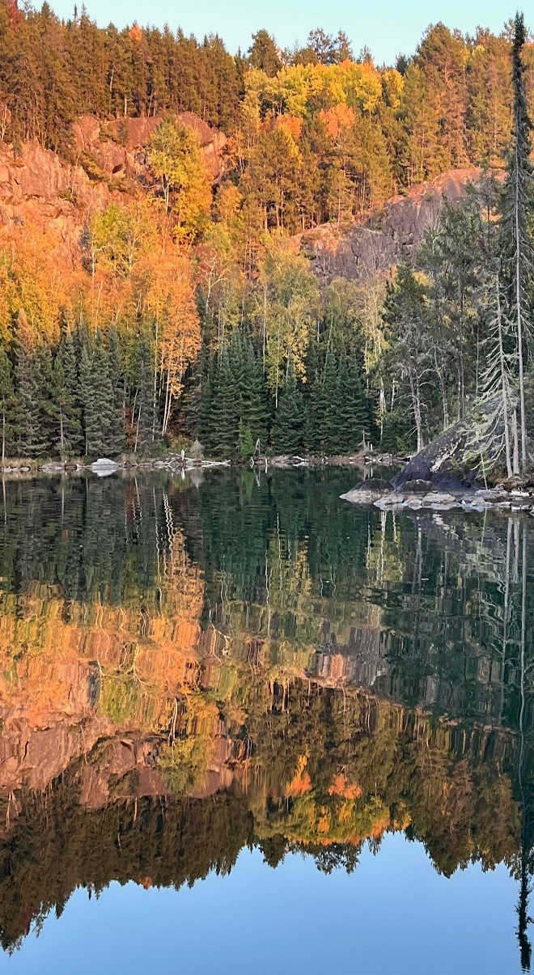

- Strategy for Education and Outreach

Through education and outreach the MRBB will strategically be a conduit for the voices of the basin by taking actions to identify issues at the basin scale. The MRBB will raise the profile of the MRBB’s work to ensure the continued significance of the MRBB’s role.

What do we gain by working together:
- We will amplify and raise the profiles of the issues through a collective voice.
- We will provide a unified delivery of messages to foster greater engagement.
- Collectively, we will build and enhance trust especially by braiding diverse ways of knowing based on Indigenous Knowledge and Science.
- We strive to ensure accountability of the collective to the people and communities who live in the basin.

Benefits of realizing strategy:
The MRBB will be able to share the vision more broadly and provide direction on the strategic objectives through communicating with others and receiving feedback and stakeholder input. By being a conduit for the voices of the people on the land the MRBB can drive research initiatives and influence investment opportunities.

- Strategic Investments & Partnerships

The MRBB will strategically position its efforts to shape and influence how funding and investments are distributed in the Mackenzie Basin. The MRBB will develop a Mackenzie Basin strategic investment plan that identifies funding opportunities with the goal of leveraging partnerships to increase funding and investment throughout the basin and ensure operational readiness to influence investments in the basin and optimize resources of governments and partners.

What do we gain by working together:
- There is a greater incentive to drive investment into multi-jurisdictional endeavors, such as those undertaken by the MRBB.
- The whole basin can benefit from leveraging the individual investments of its members to address broader basin-wide challenges.
- Promoting investments in monitoring, science, Indigenous knowledge and on-the-ground restoration actions by members or in subbasins benefits the entire system.

Benefits of realizing strategy:
Being better positioned to acquire new investments and funding to support work by the MRBB for basin-wide initiatives will achieve better desired outcomes. Having a strategic investment plan can position the MRBB to advocate for securing new and enhanced investments. Increasing investments in the basin will result in better environmental, and social health and wellbeing outcomes.

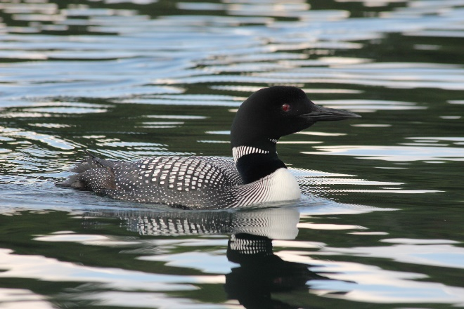

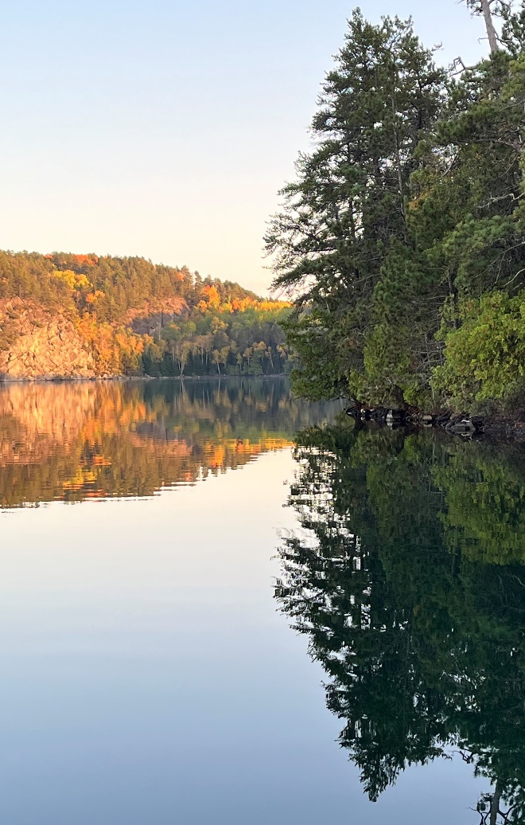

- Social Health & Wellbeing

The MRBB will strategically build a better understanding of and raise awareness of the aquatic environmental impacts to the social health and wellbeing of communities in the basin and recommend strategies to reduce or mitigate the impacts to social health and well-being.

What do we gain by working together:
- We can synthesize information and risks at a broader scale to help where addressing issues and problems at individual subbasins are challenged.
- We can enhance awareness of the risks in the various jurisdictions with a view to people’s health and wellbeing by drawing attention to the significant issues communities are facing.
- We create a platform to strengthen linkages between social and natural sciences for the benefit of people who live in the basin.
- We are building relationships for our collective and mutual benefit.

Benefits of realizing strategy:
By gathering information and data to better understand impacts to social health and wellbeing, the MRBB can inform policy changes aimed at improving people’s health and wellbeing. The work will also raise the profile of social health and wellbeing of the communities within the basin and ensure there are multiple channels for communication.

The MRBB’s Accountability
- The MRBB is obligated to produce the State of Aquatic Ecosystem Report on a five-year cycle.
- The MRBB is obligated to report annually to Ministers
- The MRBB will review its performance against the Strategic Plan every three years. Evaluation tools that include community feedback, website analysis, external reviews and surveys may be used to monitor and measure success.

ANNEX – Action Plan Commitments
ACTION PLAN | Resources/Lead
Complete Bilateral Agreements | SK/NWT  AB/SK  BC/AB
Commitment on reconciliation
Undertake broader engagement with Indigenous organizations and communities in the basin | MRBB
Seek to align governance and work to consider the United Nations Declaration on the Rights of Indigenous peoples | MRBB
Document and adopt changes using flexibility offered in the Master Agreement such as the way Indigenous peoples can nominate members to the MRBB. | MRBB
Ensure that responsibilities are defined and supported for the role of Indigenous members representing their perspectives. | MRBB
Commitment on Climate Change
In alignment with Bilateral Management committee work complete a literature review of climate research in the basin to inform baseline understanding | Secretariat
Continue to bring experts together through webinars and panel discussions  Organize Knowledge Symposiums on three-year cycles | Secretariat and MRBB
Advocate for Northern Research  Identify opportunities for MRBB or Secretariat | MRBB
Document Indigenous perspectives on the land  Committee members and/or Secretariat visit at least one community every two years to build relationships and understand engagement preferences | SOAER Committee
Commitment to Education and Outreach
Commit to ongoing educational and Traditional Knowledge webinar series  Organize annual webinar(s) | Secretariat
Actively seek out public outreach opportunities and report on these events in the annual report | All members
Actively promote the MRBBs work | Secretariat
Develop an enduring communication and outreach strategy | Secretariat
Commitment to enhancing Strategic Investments and Partnerships
Commitment to seeking member investments increased to align with inflation | Government Representatives
Track member’s investments in bilateral agreements | Government Representatives
Organize Ministers’ meeting to renew commitments | Government Representatives
Develop a baseline of environmental investments made by member governments | Government Representatives
Identify priorities for new investment opportunities through development of a Strategic Investment Plan | Government Representatives
Track and evaluate enhanced resource investments over time | Secretariat
Commitment to support social health and wellbeing of basin residents
Commit to documenting Indigenous perspectives on social health and wellbeing in the basin | All members
Consolidate data on social health and wellbeing | Secretariat
Identify impacts on social health and wellbeing that are linked to climate change | Secretariat
Raise the profile of severity of impacts on communities from fires, floods, and droughts in the basin | All members

