Water Quality Task Team Evolution: Bridging Knowledge and Building Networks
Objective: Consider how WQTT membership could change and describe potential changes to mandate, priorities, and roles.
Background
- In 2018 MRBB members agreed to support the establishment of a water quality task team.
- Main objective is to develop consistent approaches for the assessment of water quality across jurisdictions to support BWMAs.
- 2019 letter MRBB members from the Government of Alberta and Government of Northwest Territories outlines membership and list of proposed tasks. Includes a bullet on assessing water quality with science and Traditional Knowledge.
- Committee was directed to hold an initial meeting with TKSP members to “ensure that Traditional Knowledge and Indigenous perspectives on water quality contribute to the anticipated work.”
- At Meeting 81, MRBB members asked the MRBB Secretariat to consider how the Water Quality Task Team could expand to include Indigenous non-public servants.
- MRBB members have agreed to include Indigenous members (non-public servants) on the WQTT.
Analysis and discussion (to date)
The MRBB Secretariat drafted material that responded to questions raised at Meeting 81 and considered the Water Quality Task Team current terms of reference (included at the end of this document). Paula, Julian and Corinne met on April 10, 2025, to discuss a path forward.
Summary: The Water Quality task team members are currently focused only on science-based questions but there is interest in broadening that discussion. Other groups under the umbrella of the MRBB are working with different knowledge systems to advance shared goals (e.g. Indigenous Community Based Monitoring) and developing advice on respectful approaches to working Indigenous Knowledge (e.g. Way Finding Guide).
The WQTT should continue to focus on water quality and broaden scope to consider water quality through the lens of different knowledge systems. WQTT members are not responsible for braiding information but could provide advice and expertise, or a link to other MRBB related work where knowledge is being braided.
1) Propose the following changes to membership
Membership
The WQTT was originally envisioned as including members from jurisdictions only. From that perspective it was advised that members should:
- have experience in the evaluation and reporting of water quality;
- be familiar with transboundary water management;
- share the work of the WQTT with their respective organization or government (new)
- be curious about bridging/braiding of different knowledge systems (new)
- be able to consult within their respective jurisdiction and bridge information flow between the Board and the provincial/territorial colleagues (government members only)
2) Ask for nominations of an Indigenous non-public servant from MRBB members.
________________________________________________________________________________________
WQTT and Strategic Priorities
How would expanding the membership advance MRBB Strategic Priorities?
Education and Outreach
- Learning from each other
- Knowledge sharing webinars
Reconciliation
- Bridging/Braiding knowledge
- Strength in multiple knowledge systems
Social Health and Wellbeing
- Trust and relationships at the technical level
Climate Change
- BMC connection
- SOAER update
Education and Outreach
- Capacity Building
- Sharing/Compiling resources

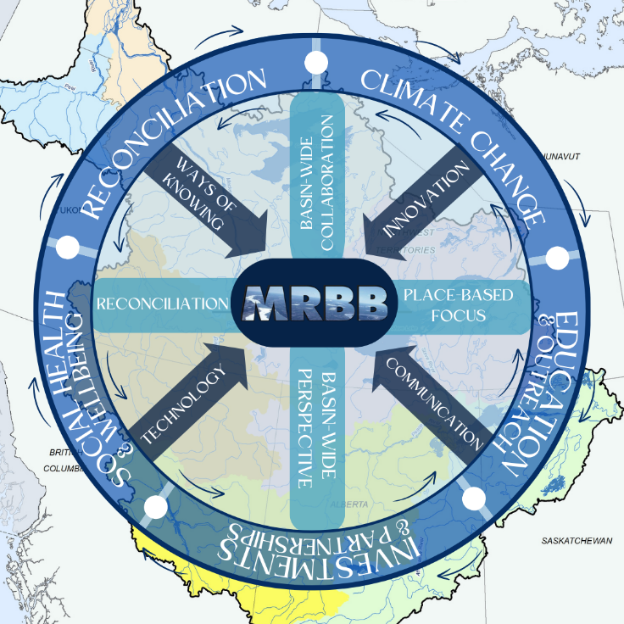

Current Mandate and Objectives
Q: How does a change in membership benefit the MRBB, and the WQTT?
A: Two-way exchange of information; support bridging of knowledge systems in communities/sub-basins; scoping of parameters/indicators to ones that are important for the people of the MRB; trust and relationship building at the technical level.
The mandate of the MRBB Water Quality Task Team (MRBB-WQTT, referred here as “the Task Team”) is to promote greater communication, coordination, and consistency of data analysis, interpretation and reporting of water quality for achieving the principles of the Mackenzie River Basin Transboundary Waters Master Agreement.

The Task Team’s objectives are to:

- provide a forum for communication and information exchange on water quality,
- recommend basin-wide agreed-to approaches to assess water quality,
- develop reporting tools that support the State of Aquatic Ecosystem report (SOAER) and
BWMA annual reporting requirements.
Q: Do the current mandate/objectives allow for inclusion of different knowledge systems.
A: Yes. The SOAER and BWMAs are already working towards the respectful inclusion of different knowledge systems. However, consider editing mandate to be explicit.
The mandate of the MRBB Water Quality Task Team (MRBB-WQTT, referred here as “the Task Team”) is to promote communication and coordination of water quality information from different knowledge systems in the Mackenzie River Basin to support the principles of the Mackenzie River Basin Transboundary Waters Master Agreement.

Objectives:
- provide a forum for communication and information exchange on water quality,
- recommend basin-wide approaches to assess science-based water quality information,
- develop reporting tools and approaches that support the State of Aquatic Ecosystem report (SOAER) and BWMA
- support bridging/braiding of water quality information in the MRB.

This expands the scope of work that the WQTT would take on/be assigned and potentially strengthens connections to ongoing work of the BWMAs and SOAER. It continues to support a science-based discussion and creates the opportunity for this task team to explore bridging/braiding of water quality information.

Membership

The WQTT was originally envisioned as including members from jurisdictions only. From that perspective it was advised that members should:
- have experience in the evaluation and reporting of water quality;
- be familiar with transboundary water management; and
- be able to consult within their respective jurisdictions and bridge information flow between the Board and the provincial/territorial colleagues.
Q: Are these still relevant for government members? Are additional bullets required? What about Indigenous non-public servants?
A: Probably. Recommend the following addition
- Be curious about bridging/braiding of different knowledge systems
Suggest the following as skill set for Indigenous member
- have experience in the evaluation and reporting of water quality;
- share the work of the WQTT with their respective organization or government
- be curious about bridging/braiding of different knowledge systems

Roles
Chair: The Task Team Chair will circulate meeting agendas and informal meeting notes for Task Team meetings. The Task Team Chair will facilitate meetings unless a designate is required.
Meeting objectives will be clear and articulate what the Task Team needs to do, what it needs to learn from others, or what it needs to understand. Action items will be reviewed at the end of a meeting. Meeting minutes will be circulated after the meeting.
Task Team members: are expected to attend and participate in all meetings. Task Team members will notify the chair if they are unable to attend a meeting. In preparation for meetings, Task Team members shall review relevant information and be prepared to fully participate. Members of the Task Team are expected to provide comments or other feedback as requested on circulated materials where appropriate.
Provincial/Territorial MRBB members: Identify and nominate individuals for the WQTT. Could be approached collaboratively.
Federal MRBB Members: Identify a chair and note taker for the WQTT.
MRBB Secretariat: Attend meetings. provide oversight, could provide temporary Secretariat support.

