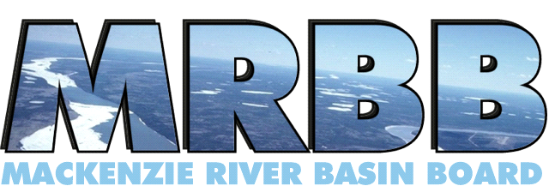

The Board’s Vision: A healthy and diverse aquatic ecosystem

for the benefit of present and future generations.

DATE

Dear colleagues:

I am writing to you today as INSERT’s Indigenous member on the Mackenzie River Basin Board (MRBB). I was appointed in INSERT for a term of INSERT years. I’m of INSERT ancestry and am located in INSERT.

The MRBB was established to implement the Mackenzie River Basin Transboundary Waters Master Agreement (Master Agreement) which was signed by the governments of Canada, British Columbia, Alberta, Saskatchewan, Yukon and the Northwest Territories in 1997. The agreement commits the six governments to share knowledge and cooperatively manage water to maintain a healthy and diverse aquatic ecosystem throughout the Mackenize River Basin. The Board has 13 members, representing federal, provincial, territorial and Indigenous perspectives ([ht](https://www.mrbb.ca/ht)tps://www.mrbb.ca/).

The MRBB publishes a report on the state of the aquatic ecosystem of the Mackenzie River Basin for Ministers, Indigenous leadership, scientists, and the public. In 2021, the MRBB published an online State of the Aquatic Ecosystem Report (SOAER) that braided publicly available science and Indigenous knowledge for four aquatic indicators: water quality, water quantity, habitat and species, and health and wellbeing. Please visit the SOAER website ([<https://soaer.ca/>](https://soaer.ca/)) to learn more.

The MRBB is preparing for an update to the 2021 SOAER. I am a member of two MRRB committees that guide development and updates to the SOAER. They are the Traditional Knowledge and Strengthening Partnerships Committee and the State of the Aquatic Ecosystem Report Committee.

The report update will focus on the same four aquatic indicators included in the 2021 report, informed by a series of signs and signals (Figure 1). While many foundational pieces will remain, the update includes plans to fill data gaps, improve maps, enhance information on climate change, permafrost and ice, and add audio and video content. The MRBB hopes to profile Indigenous knowledge and science shared by people living in the basin. This could take a number of different forms such as linking to material that is already available on the internet, and uploading previously collected audio or video to the SOAER website. We would also like to know if you are interested in sharing information but need support to do so. The MRBB is not a funding agency but can write letters of support or may be able to connect you with partners that could provide support.

Figure 1 – MRBB State of the Aquatic Ecosystem Report Indicators, Signs and Signals.

The MRBB will meet virtually in early October and mid November 2025. If you require further information on the Board and its committee(s) please contact Paula Siwik ([paula.siwik@cwa-aec.gc.ca](mailto:paula.siwik@cwa-aec.gc.ca)) or Jeffrey Cederwall ([Jeffrey.cederwall@cwa-aec.gc.ca](mailto:Jeffrey.cederwall@cwa-aec.gc.ca)) from the MRBB Secretariat. They would be happy to do a presentation on the 2021 SOAER and discuss the SOAER update. If you have any questions, suggestions or issues that you would like me to share on your behalf with the MRBB, please let me know.

Sincerely,

INSERT Indigenous Member, Mackenzie River Basin Board (MRBB)

cc.